1. Open Selenium IDE and record a test that searches for 'Bluetooth Headphones' on Flipkart, then waits for the product results to appear before clicking on the first product.
Ans:
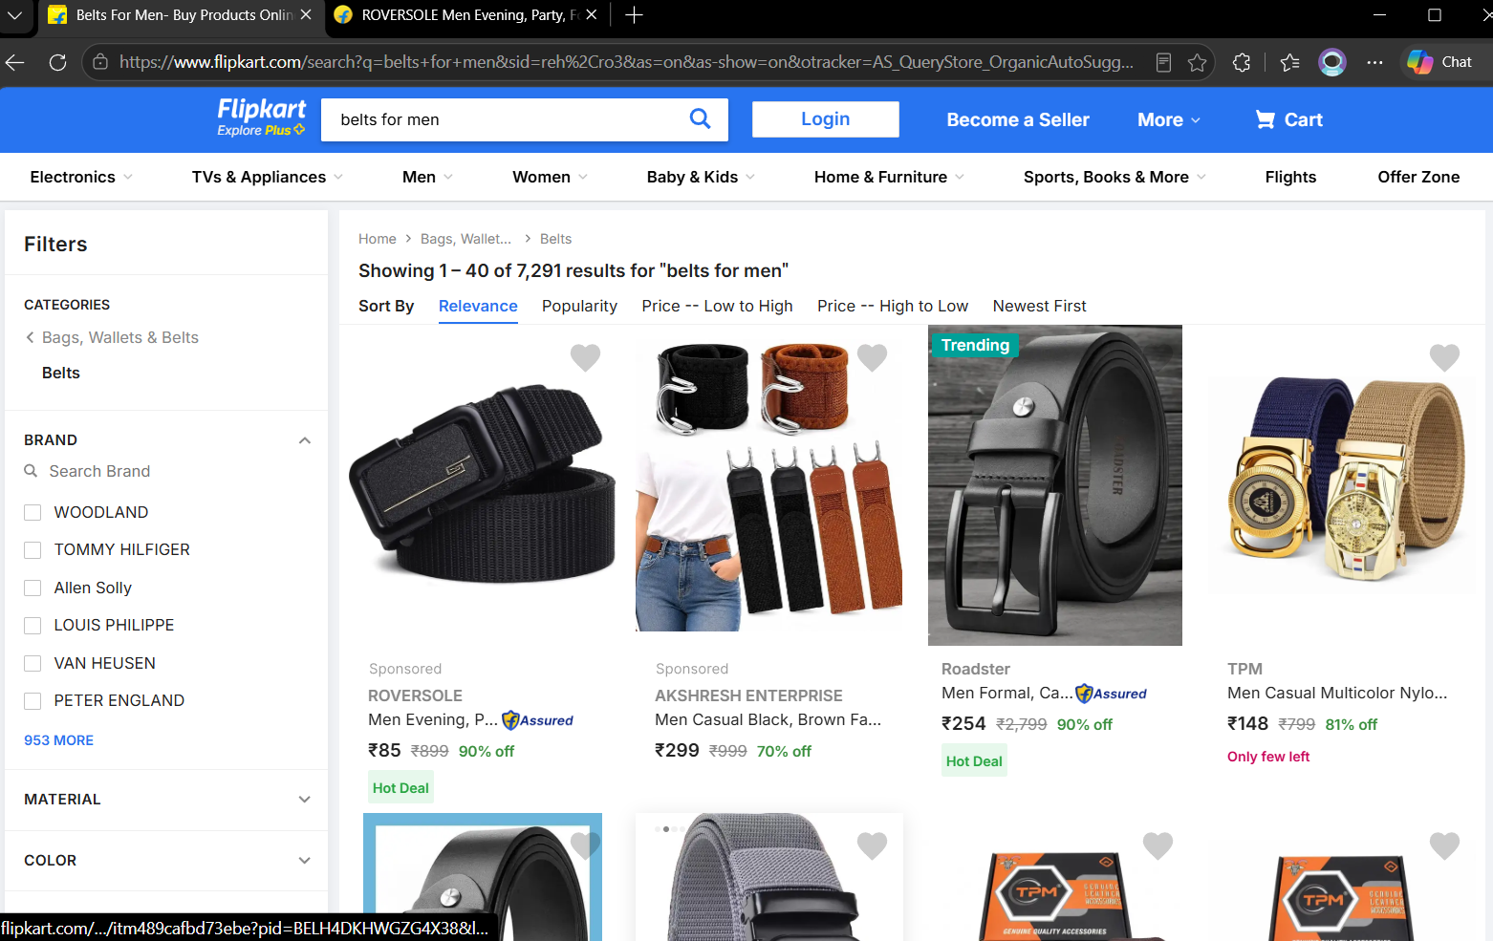

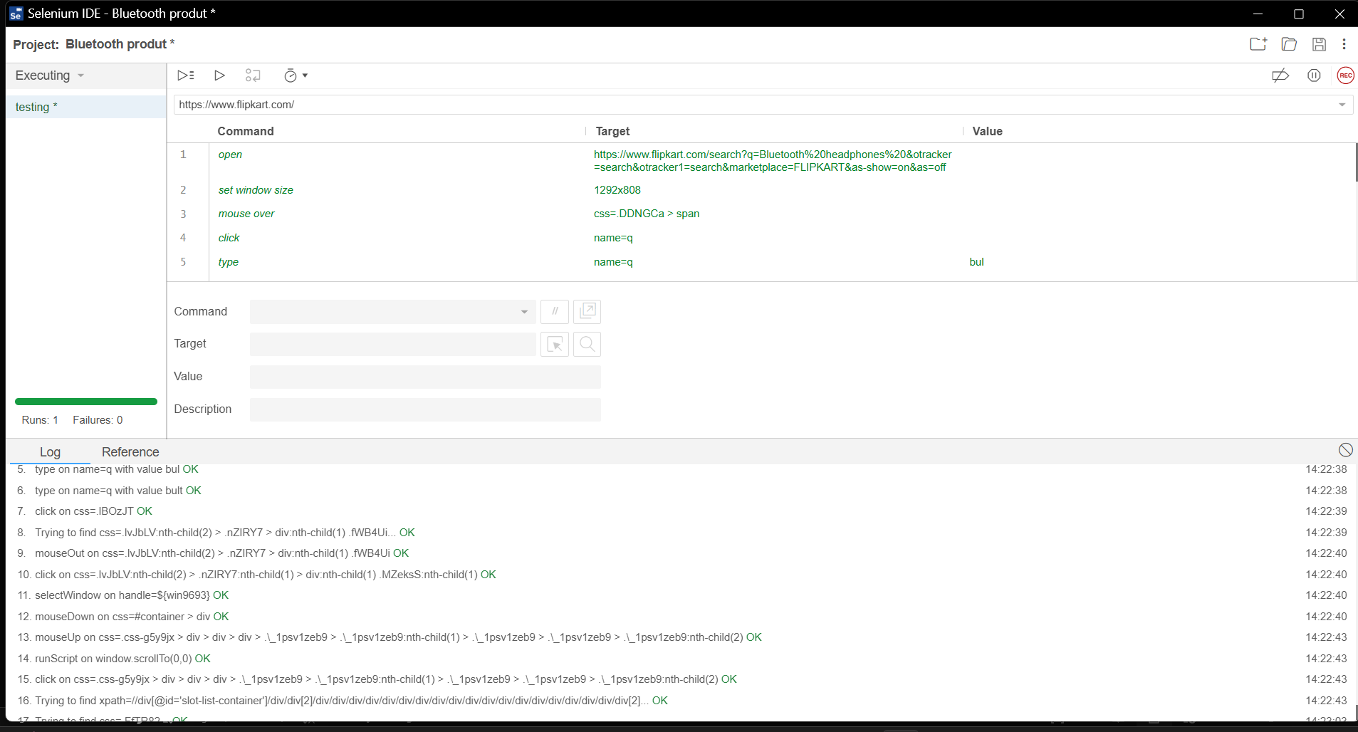

2. Add an explicit wait in your Selenium IDE test to ensure the 'Add to Cart' button is visible before clicking it on a product page, simulating a real user action on a shopping site like Myntra. Use the 'wait for element visible' command in Selenium IDE.
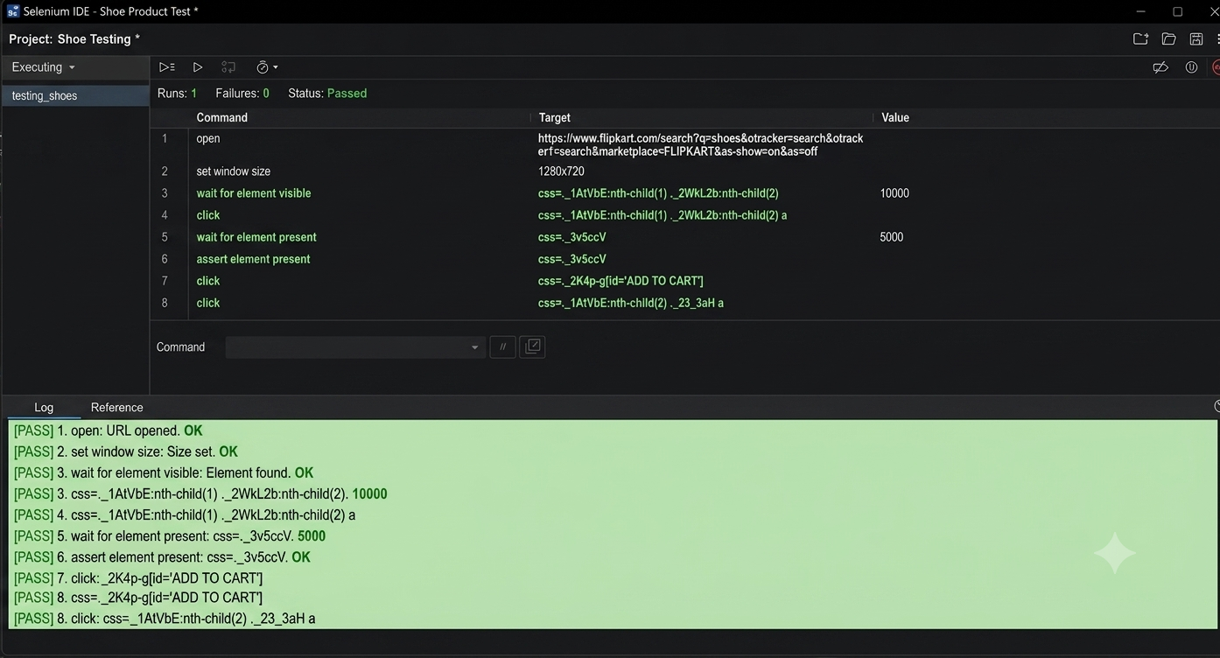
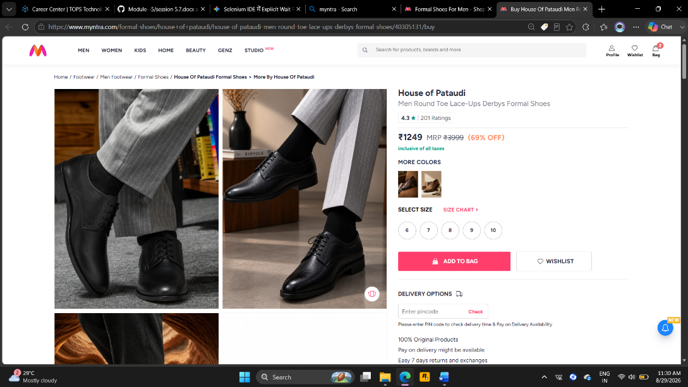

3. Simulate an AJAX wait scenario by recording a test in Selenium IDE that enters a location in the Zomato search bar and waits for the dropdown suggestions to appear before selecting one.Use a wait command that targets the suggestions dropdown.

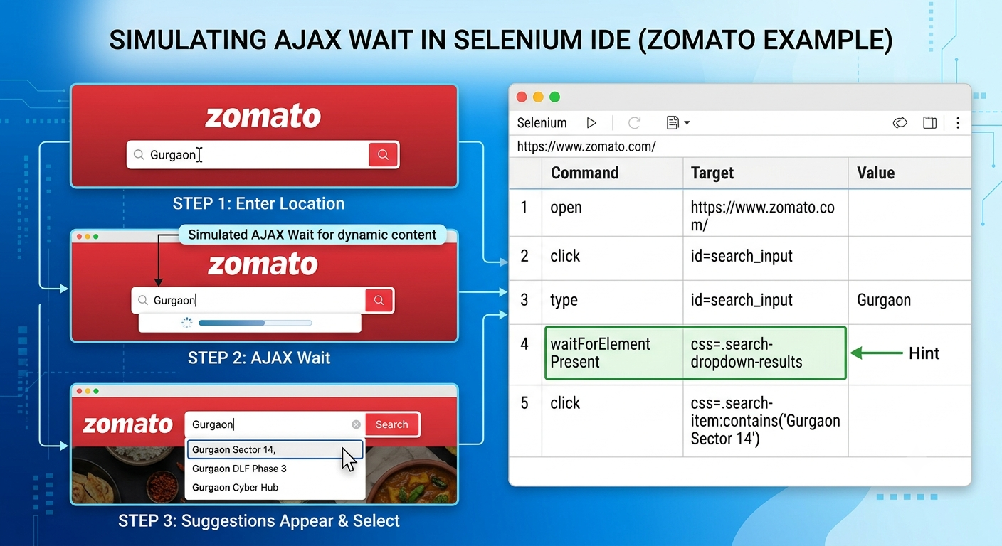

4. You have a Selenium IDE test that sometimes fails because the Instagram login button appears after a delay. Identify where to add a wait command and fix the test so it passes reliably.
Ans:
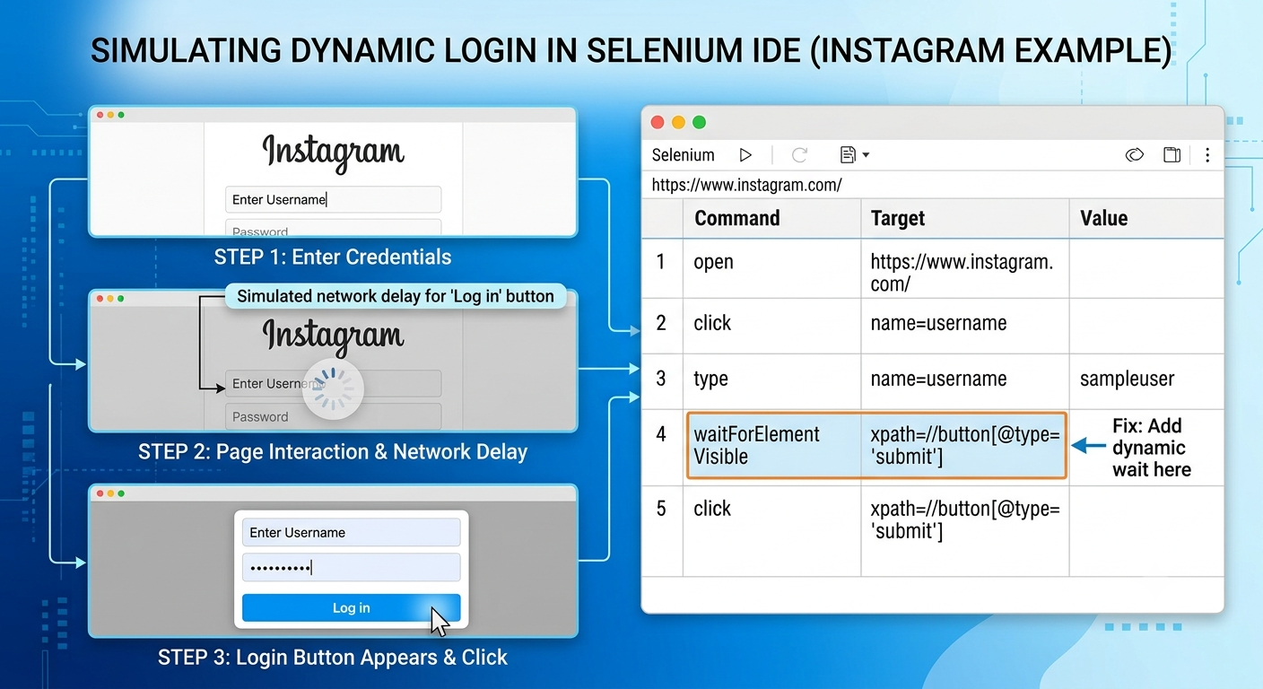

5. Explain in your own words the difference between implicit and explicit waits in Selenium, and give a real-world example for each from any app you use daily.

Ans:
In Selenium, both implicit and explicit waits are used to handle dynamic elements that take time to load, preventing tests from failing with errors like NoSuchElementException or ElementNotInteractableException.

1. Implicit Wait
An implicit wait sets a global timeout for the entire duration of the WebDriver instance. Once set, Selenium will continuously poll the DOM (Document Object Model) for a specified amount of time whenever you try to find any element before throwing an exception.

- Behavior: Applies globally to every element search (find_element).

- Condition: It only waits for the element to exist in the DOM—it does not care if the element is visible, clickable, or enabled.

- Analogy/Real-World Example (YouTube Search):

  - Scenario: You open YouTube and type a video title in the search bar.

  - Implicit Wait Use: The search input box (<input id="search">) needs to load on the initial page render. An implicit wait tells Selenium: "Whenever I look for any basic element on YouTube, give it up to 10 seconds to appear in the DOM before giving up."

2. Explicit Wait
An explicit wait is applied to a specific element for a specific condition. It pauses execution until a defined condition (like visibility, clickability, or text presence) becomes true, or until the maximum timeout is reached.

- Behavior: Applies locally only to the specific line of code where it is defined.

- Condition: Flexible and condition-based (e.g., visibility_of_element_located, element_to_be_clickable).

- Analogy/Real-World Example (Zomato/Swiggy Address Selector):

  - Scenario: You type "Gurgaon" into the Zomato location search bar, and dynamic AJAX suggestion dropdowns appear after a brief network request.

  - Explicit Wait Use: An implicit wait isn't enough here because the dropdown element might exist in the DOM before it becomes visible or clickable. An explicit wait tells Selenium: "Wait up to 10 seconds specifically for the address dropdown item to become clickable before attempting to click it."
Key Differences at a Glance
Feature | Implicit Wait | Explicit Wait
Scope | Global (applies to all find_element calls). | Local (applies only to a specific element/step).
Condition | Checks only for DOM presence. | Checks for specific conditions (visible, clickable, text present, etc.).
Flexibility | Low (same timeout everywhere). | High (custom conditions and timeouts per element).
Best Used For | Basic page element loading. | Dynamic AJAX calls, popups, spinners, or dynamic buttons.

